A brand that I am familiar with is Forever 21. The brand strategy is monolithic, and there is one brand associated with all the clothes in the store, but there are several sub-brands in the store as well. The attributes I associate with the brand are trendy, low-pricing, and fast-fashion. Forever 21 always has the latest clothing styles and they always have reasonable pricing. Fast fashion is the idea that the clothing is reasonably priced but the quality of the clothing is not as good and therefore has to be discarded and replaced soon. The brand identifies itself with a word mark. Forever 21 advertises through the web effectively through various side bar ads. The brand also uses email and texting, and sometimes over does it, and sends promotions and coupons through those mediums. They sometimes advertise through the TV, but not nearly as much.
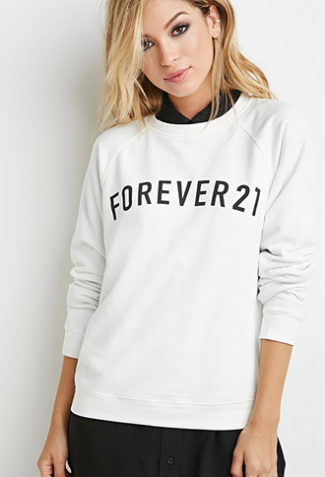
The typographic approach used is san serif. The serifs are eliminated from the text giving the text a sleek appearance, to fit the fast fashion, trendy identity the brand is going for. The hierarchy is communicated through the orientation in space as well as the size, and weight of the text. The text is heavy and bolded and is usually in the center of the tag or the bottom of the bag/ on top of shirts. The text can be read instantly, and it directly relates to the fast fashion idea. The text is usually by itself and simple. It is usually accompanied with a yellow background to further emphasize the text. The typeface gives a clear idea of the brand to the customers to help them remember the name. The colors are clearly saturated and the brand uses a warm color (yellow) and a neutral color (black). The colors are simple, so that the idea that the brand is simple and the clothes are simple and meant to be worn a few times and discarded.

